L04 Participation Assignment – functions

Background
Explore the use of fuctions.

Procedure
Answer the following questions.

- Review the following code that calculates adding tax to the price of an item. Copy the code to a Python file and ensure it works as expected.
## tax.no_function.py
done = False
while not done:
sentinel = str.upper(input(f'Enter Q for quit or any other key to compute tax '))
if sentinel == 'Q':
done = True
print(sentinel,done)
continue
else:
print("Compute tax")
price = float(input('What is the price '))
tax = float(input('What is the tax rate? '))
calculated_price = price * (100 + tax) / 100
print(f'The calculated price is {calculated_price}')

- Rewrite the tax.no_function.py module using a function for get_inputs() and calculate_price_with_tax(). Paste your code here:
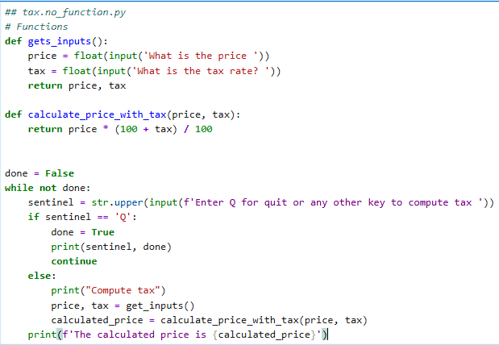

- Create a Python module with a function named add_mult(). (refer to L04 slide #18)
  - Pass in two parameters
  - Return x + y and x* y
  - Print the add_mult function while passing in 10, 20
  - Paste code below:
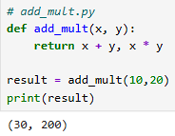

- (optional – do not have to complete) Rewrite the return.addmult program using a lambda function.
  - Paste code below:
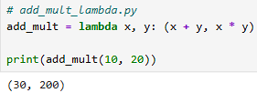

- Submit this word document to Canvas.

